# woman technologist Day 2: JS + Tools + Product



**WIFI** cowork @ lisboa

**PASSWORD**: 1familiainvicta

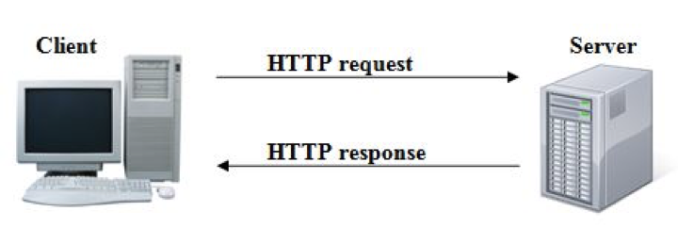

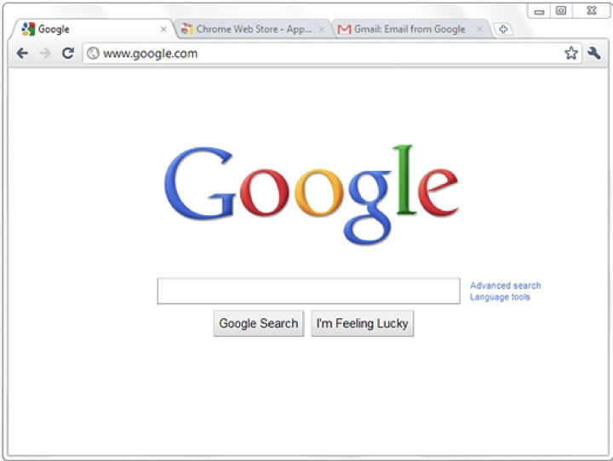

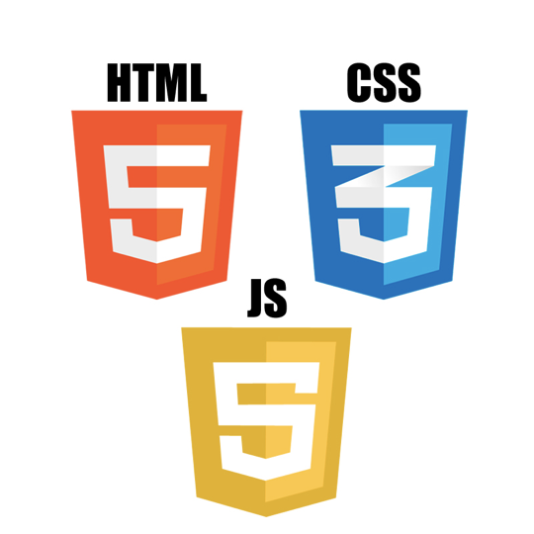





# waving hand Welcome back

# hot beveragechocolate bar Isabel

# high voltage Filipa

# airplane Rita

# red heart Sofia

# party popper Catarina

# man lifting weights Elina

# penguin Sandra

# grinning cat face with smiling eyes Maria

# woman dancing Carolina

# heart decoration Ana

# books Deanna

# woman detective Andrea

# face with tears of joy Carla

# smiling face with open mouth Anabela

# winking face Isabel

# grimacing face Sara

# speak-no-evil monkey Catarina

# rolling on the floor laughing Raquel

# person facepalming Daniela

# star-struck Mariana

# person shrugging Joana

# broccoliclinking beer mugs Lea

# unicorn face Nathalia

# fox face Maria

# 

# calendar Program of the day

* JavaScrip
* Project
* Wine 

# weary cat face Yesterday

## HTML Page

<html>

  <head>

    <title>Title of the document</title>

  </head>

  <body>

    The content of the document......

  </body>

</html>

## HTML Element

<div>

  Cum sociis natoque penatibus e

</div>

<ul>

  <li>

    Paris

  </li>

  <li>

    New York

  </li>

  <li>

    Lisbon

  </li>

</ul>

## HTML Attrbitues

<a href="https://twitter.com/dellacm">My Twitter</a>

## HTML Classes

# 

<ul>

  <li class="europe">

    Paris

  </li>

  <li>

    New York

  </li>

  <li class="europe">

    Lisbon

  </li>

</ul>

# 

a.europe {

  color: blue;

}

# 

# 

# person taking bathHomework + Clean code

<https://docs.google.com/forms/d/1KJLniV05NxnpPj8dLgi0O-w6sUHD5Jrm3QEu3zpAH5U/edit#responses>

# Programming language







## exclamation question mark Why do we need JavaScript?

Facebook / Google?

## Console

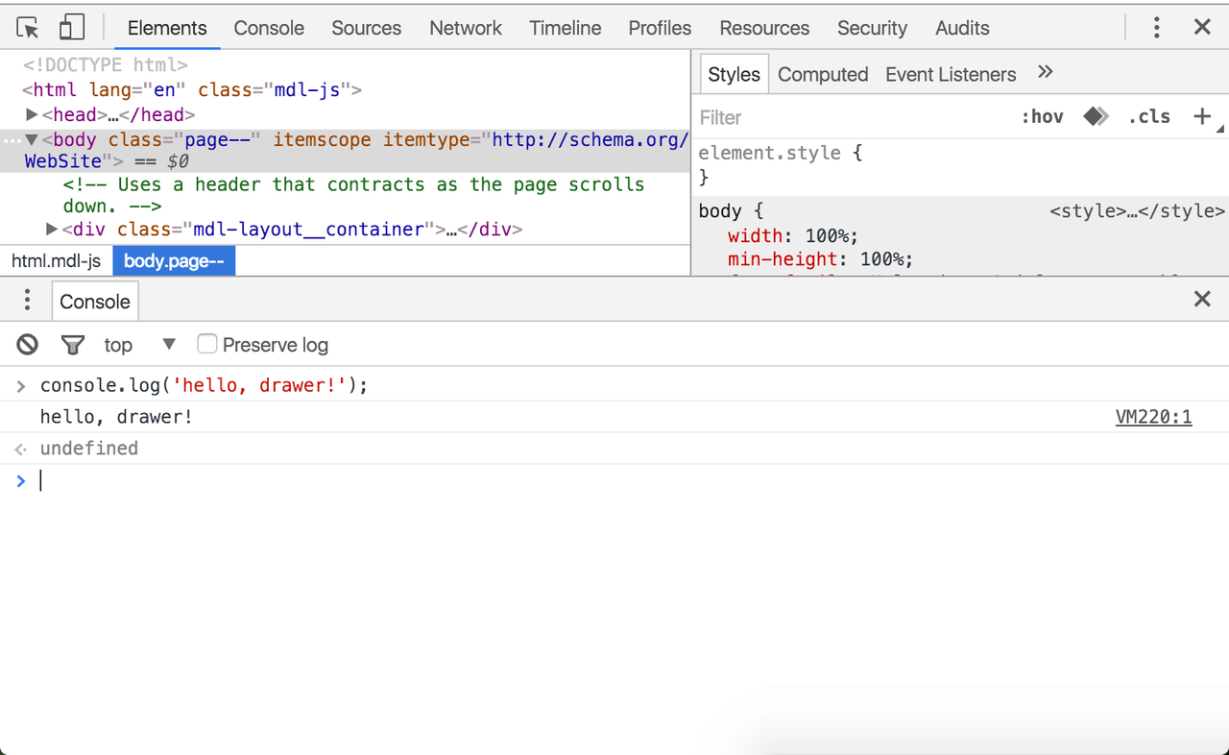

## Variable

let x = 1;

let y = 3;

let name = 'Will';

const city = 'Lisbon';

## hammer and wrench Exercise

Create a variable called city with you hometown in it

## Variable operations

x + y

city + country

## hammer and wrench Exercise

Create a variable called city and country with you hometown and country and output a sentence  sentence including the 2 variables such as **I am from Toulouse, in France**

## Alert & Prompts

prompt();

alert('test');

## hammer and wrench Exercise

1. Create a prompt asking for your hometown and alert the hometown
2. Ask for your first name and last name. Alert your full name

let firstname = prompt('What is your first name');

let lastName = prompt('What is your last name');

let fullName = firstName + ' ' + lastName;

alert(fullName);

## 

## Types

Number: Integer, Float

String 30 !== '30' 30 + '1'

Boolean

Array

Object

undefined

Null

NaN (not a number)

## Empty values

let name = '';

## Comparator

<=

>=

===

!==

x + y === 4;

## Comments

// this is a comment

/*

  this is a comment

*/

## If statements

let age = prompt('How old are you?');

if (age < 18) {

}

if (age >= 18) {

}

## hammer and wrench Exercise

Ask for your age and if you are below 18, alert **You cannot apply,** if you are 18 or more, alert **You can apply**

let age = prompt('enter your age');

if (age < 18) {

  alert('You cannot apply');

}

if (age >= 18) {

  alert('You can apply');

}

## If else statements

age = 14;

if (age < 18) {

  alert('You cannot apply');

} else {

  alert('You can apply');

}

if (age <= 18) {

  alert("you can't apply");

} else {

  if (age > 90) {

    alert("you can't apply, you're too old");  }

} else {

 alert('you can apply');

}

## hammer and wrench Exercise

Ask for the current hour: (i.e 14)

If it’s before 12, alert **Good morning**, else **Hello**

let hour = 13;

if (hour < 12) {

  alert('Good morning');

} else {

  if (hour >= 18) {

    alert('Good evening');

  } else {

    alert('Good afternoon');

  }

}

## And VS Or

if (age < 18 || age >= 90) {

    alert("you can't apply");

} else {

 alert('you can apply');

}

if (continent === 'Europe' && language === 'Portuguese') {

  alert('You are from Portugal');

}

## hammer and wrench Exercise

Ask for your What country are you from in a prompt

Alert ‘You speak p*ortuguese*’ if you are from **Brazil** or **Portugal**

Alert ‘*You speak another language*’ otherwise

## Script tag

<script></script>

## Console log

console.log(test + ‘test’)

## Functions

Piece of code that does one or more actions

function go() {

  alert('hi');

}

go();

function go(name) {

  alert('hi ' + name);

}

go('Matilde');

function go(name, age) {

  alert('hi ' + name);

  alert('happy ' + age + 'th birthday');

}

go('Matilde', 18);

## hammer and wrench Exercise

1. Create a function `canSpeakPortuguese` asking for your country and alerting ‘You speak *Portuguese*’ if  from **Brazil** or **Portugal** or ‘*You speak another language*’ otherwise

function substract(numberOne, numberTwo) {

  alert(numberOne - numberTwo);

}

substract(10, 7);

## 

## Functions

Piece of code that does one or more actions

function go() {

  alert('hi');

}

go();

function substract(numberOne, numberTwo) {

  alert(numberOne - numberTwo);

}

substract(10, 7);

## Exercise

1. Download <https://goo.gl/62rd28>
2. Move the logic into a function

## Return

function add(x, y) {

  return x + y;

}

add(1, 2);

alert(add(3, 4));

let age = add(10 + 8);

## Exercise

1. Download <https://goo.gl/65nEiE>
2. Instead of alert message from the function, return true or false
3. Alert the message from outside of the function

# Selectors

document

city = document.querySelector('.city')

cities = document.querySelectorAll('.cities')

## Exercise

1. Select the h2 <https://shecodes.io/>
2. How many coders do we have listed on the page? <https://shecodes.io/coders>

## Events

document.querySelector('.blue').addEventListener('click', function() {

  alert('test');

});

mouseenter

mouseover

mousemove

mousedown

mouseup

click

dblclick

mouseleave

mouseout

## hammer and wrench Exercise

Download <https://goo.gl/62rd28>

Ask for the person’s birth year when click the apply button

<h1>Hello</h1>

// javascript

document.querySelector('h1').addEventListener('mouseenter', function() {

  alert('hello world');

});

## hammer and wrench Exercise

If the person can apply, replace the h1 by “Welcome to She Codes”

# JavaScript Frameworks

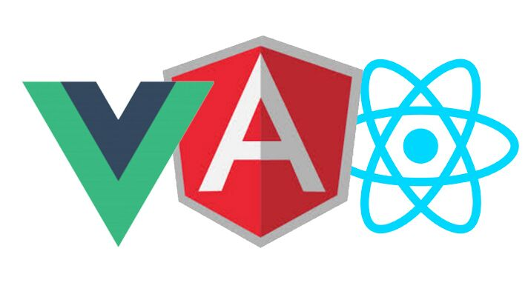

# 

# Backend language

# 



# 

## Examples

# methods

**def** **hello**

  'Hello'

**end**

# loops

names = ['Bob', 'Sue', 'Aron', 'Joseph']

names.each **do** |name|

  puts "Hello #{name}"

**end**

# HTTP request

require 'rest-client'

url = 'https://www.facebook.com/'

response = RestClient.get(url)

response.code

response.body

# 

# 

## Backend vs Frontend development

# 

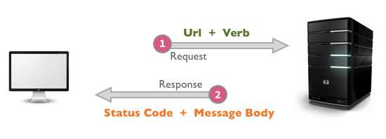

# 

# gem stone Backend

# Why Backend by the wayquestion mark

# <https://shecodes.io/>

# 

# 



# 

# radio button Complete example

## Chess game

## → <https://lichess.org/>

## Open source

## → <https://github.com/ornicar/lila>

# thinking face Do I enjoy coding?

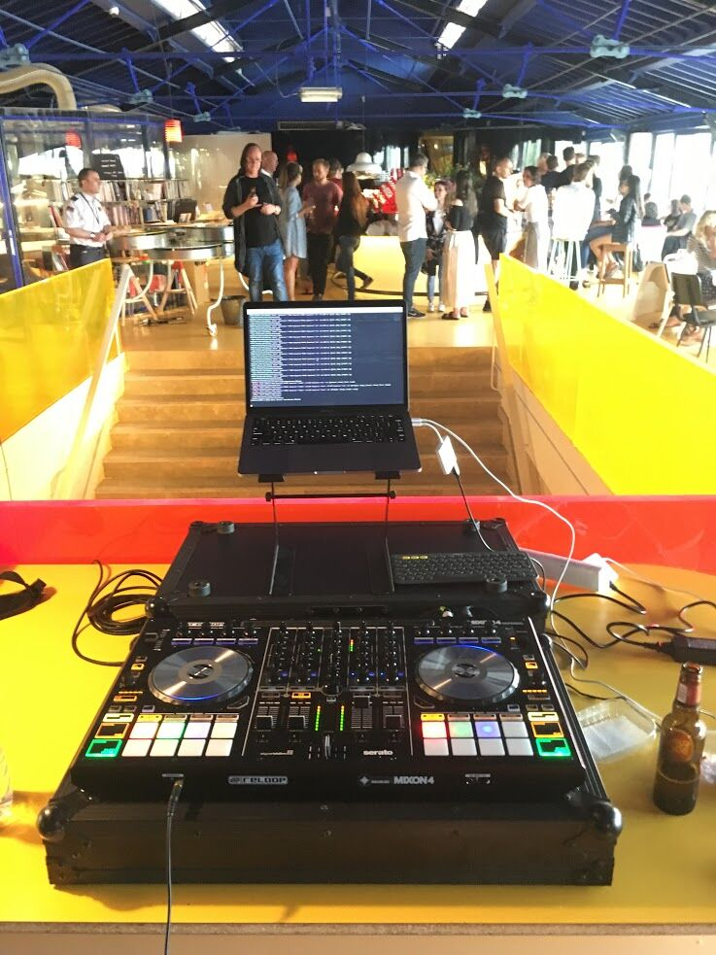

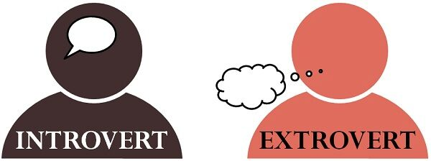

# hammer and wrench Development tools

## Visual Studio Code AKA Code

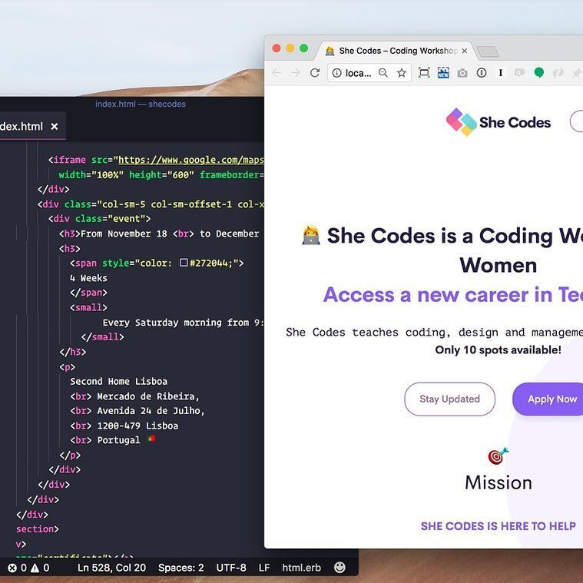

# 

## card index dividers Git

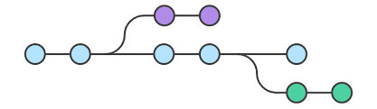

## pager Terminal

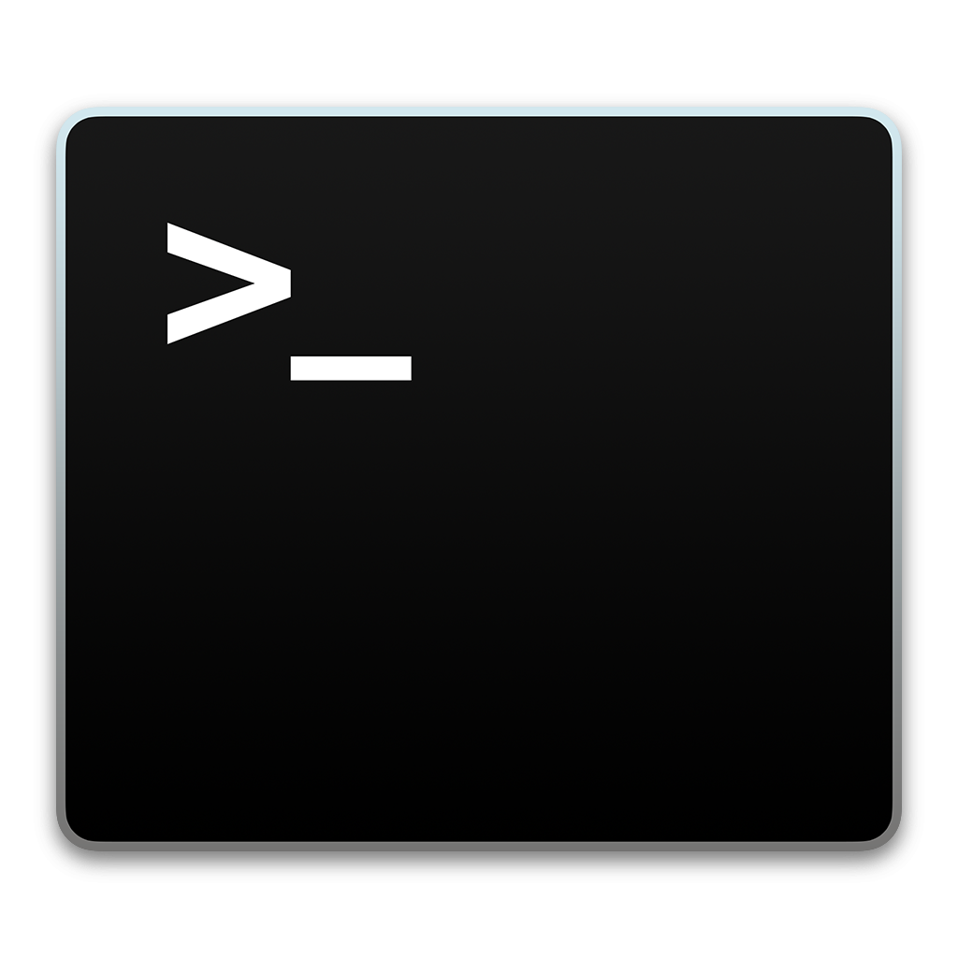

## robot face GitHub



# 

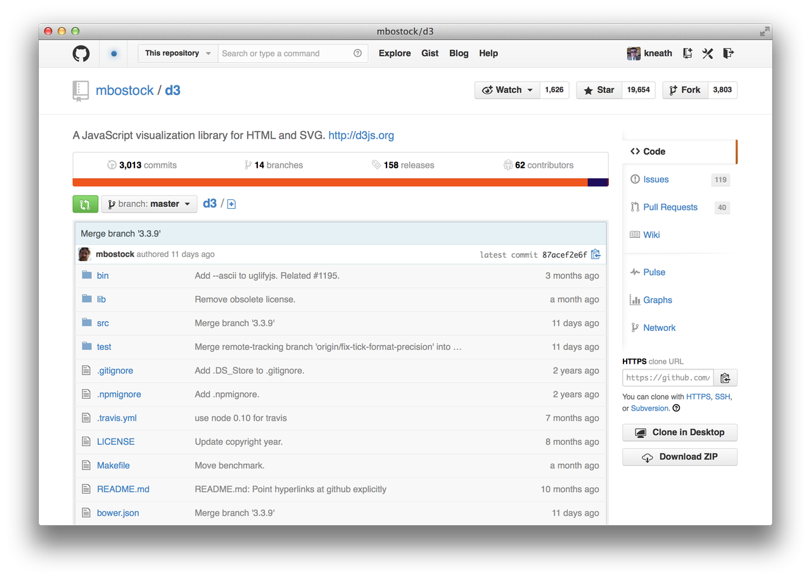

# 

# 

# fork and knife Forking an existing repo

# <https://github.com/matthieua/shecodes>

# 

## hammer and wrench Exercise

# <https://thesuprematism.com/>

1. Fork She Codes
2. <https://github.com/matthieua/shecodes>
3. Download it
4. Open in code
5. Change something
6. Launch it!

# 

# weary cat face She Codes Final Project

**DEADLINE:  15 September, midnight**

Create a landing page from scratch about something you’re passionate about. The page should include a user interaction.

## HTML requirements

**Include these the following HTML elements tags**

h1, h2, p, div, span, strong, em, br, hr, a, img, button

## CSS requirements

**Use the following CSS properties**

margin, padding, font-size, font-weight, color, background (with linear-gradient), line-height, box-shadow, border, transition

## JavaScript requirements

**Use the following JS functionalities**

let, if, else, alert, prompt, event

Submit the HTML file and the interaction instructions.

# backhand index pointing right <https://shecodes.io/project>

## two women holding hands Let’s work in pairs [#slack](https://paper.dropbox.com/?q=%23slack)

students = ['Isabel PC','Filipa','Rita','Sofia','Catarina C','Elina','Sandra','Maria M','Carolina','Ana','Deanna','Andrea','Carla','Anabela','Isabel P','Sara','Catarina B','Raquel','Daniela','Mariana','Joana','Lea','Nathalia','Maria J']

students.shuffle.each_slice(2).each do |student_one, student_two|

  puts "#{student_one} with #{student_two}"

end

# thinking face Examples

# exploding head Coders profiles

# 

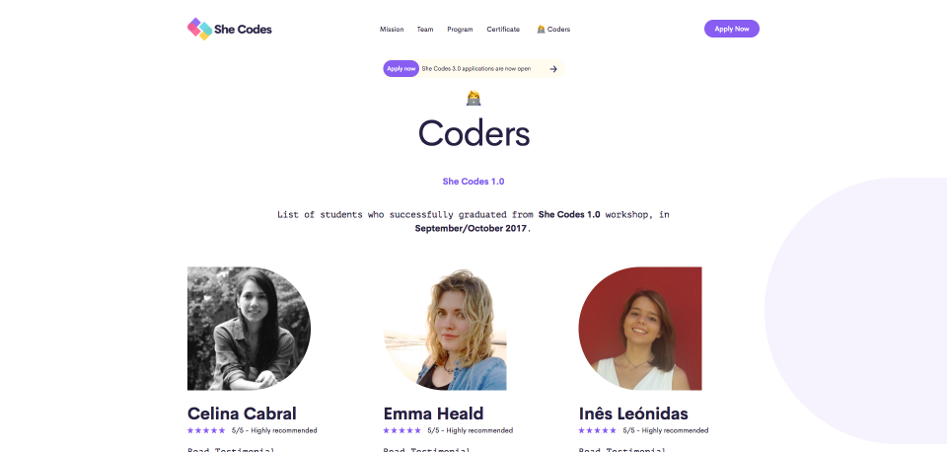

# shushing face Alumni Facebook Group

# bookmark Certificate

# flexed biceps Recommend

# → <https://shecodes.io/recommend>

# Instagram post folded hands

# 



# thinking face What’s next for you?

# Become a front-end developer

# Become a back-end developer

# Become a product manager

# Become a product designer

# Become a entrepreneur

# pouting face Or?



# 

# 

# Final thoughts

## man singer Fame

## raising handsFreedom

## man health worker Recognition

## Tokyo towerLegacy

## money bag Money

# 

# 

# 

# 

# 

# 

# 

# 

## man singer ~~Fame~~

## raising hands Freedom

## man health worker ~~Recognition~~

## Tokyo tower~~Legacy~~

## money bag Money

# 

# chequered flag She Codes 6.0

# -raising hands Thanks to the team!

## Jamie

## Beatriz

## Luis

## Daniela

## Robbie

## Marissa

## Rado

# oncoming fist You!

# 

# 

# 

# 

# 

# 

# person in bed She Codes 6.5



# 

# 

# Portugal She Codes Lisbon

## September 14 to September 28

## November 24 to December 8



# Portugal She Codes Porto

## November 17 and 18

## *Looking for a bigger venue*



# United Kingdom She Codes London

## December 15 and 16



# 

# megaphone One more thing



# 



# Overview

## Front-end: Advanced HTML/CSS

## Programming: Functions, Arrays, Loops, Events, Object Oriented, AJAX

## Back-end: Node.js

## Tools: Git, GitHub, Terminal, Hosting, Visual Code

# thinking face What to expect

## Deep understanding of web development

## Able to apply to front-end positions

## Build a real life app you can showcase to the world

# woman technologist Who can apply

For She Codes Alumni only

# calendar When

## 6 week workshop

## 6 hours class per week

## Every Tuesday and Thursday in Lisbon from 18:30 to 21:30

# money with wings How much?

## 590 euros for the workshop only

# waving hand Interested?

# Go to <https://shecodes.io/plus>



# Overview

## Basic coding: HTML, JS

## Tools: IDE, GitHub, Editors, Workflows

## Management: How to understand and lead developers

## Hiring: Tips on how to identify good developers

# calendar When

## 1 day in Portugal

## 2 days outside of Portugal

# money with wings How much?

## Contact me matt@dellac.org

# loudspeaker Spread the word, please folded hands

## Facebook: <https://www.facebook.com/shecodesio/>

# → Invite your friends

# → Like us



## Instagram: <https://www.instagram.com/shecodesio/>

# → Like our posts

# → Follow us

## Tell your friends

# → Anyone can apply

# → Recommend your friends

# → <https://shecodes.io/>

## 

# 

# 

# 

# 

# 

# 

# 

# 

# 

# 

# 

# 

# 

# 

# 

# 

# grinning face Stay in touch with She Codes

# 

# 

# Email: matt@dellac.org

# IG: @matthieu

# tw: @dellacm

# 

# 

# 

# wine glass Before Wine Time…. feedback time!

# <https://shecodes.io/feedback>

# 

# OBRIGADO!! party popper

# 



# 

# camera with flash wine glass Photo + Wine + Stickers

